Updating Tables  
DAD 220 Intro to Struct Database Env

Sergio Mateos

Southern New Hampshire University

1. Connect to the database.

1. Create the Employee table.

1. Create the Branches table.

1. Describe them.
   1. 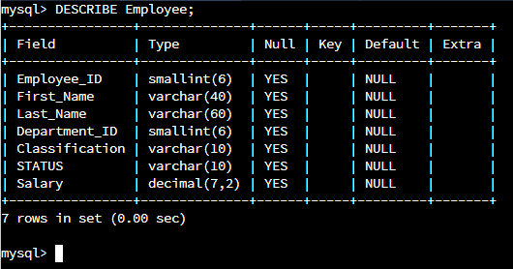Describe Employee.
   2. Graphical user interface, text

      Description automatically generatedDescribe Branches.

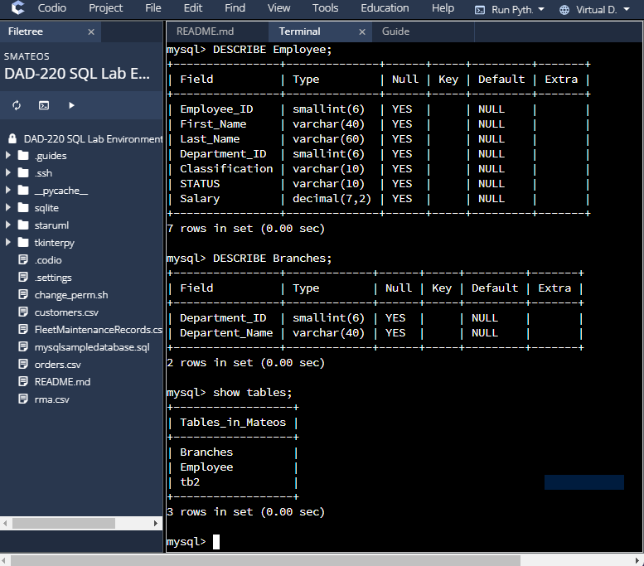

1. Insert records into the Employee table.
   1. Text

      Description automatically generatedInsert Into Employee.
   2. Diagram

      Description automatically generatedSelect* from Employee.

1. Insert records into the Employee table.
   1. Text

      Description automatically generated with low confidenceGwen Johnson: Employee ID = 103, DEPARTMENT_ID = 4, Classification = NULL, Status = Full-Time, SALARY = 40000.
   2. Text

      Description automatically generated with low confidenceMichael Jones: Employee ID = 104, DEPARTMENT_ID = 4, Classification = Non-Exempt, Status = Full-Time, SALARY = 90000
   3. Text

      Description automatically generatedInsert your name.
   4. A screenshot of a computer

      Description automatically generated with medium confidenceSelect* from Employee.
   5. Insert record for famous characters.
   6. A screenshot of a computer

      Description automatically generated with medium confidence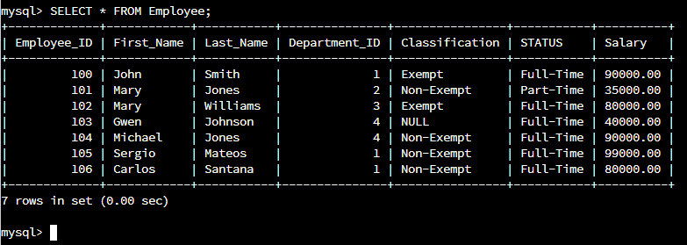Validate
2. A picture containing text

   Description automatically generatedSelect the field of the last name, first name, and department id from the table.

